**Cloud Computing**

**Cloud computing** is the **on-demand delivery** of **IT resources** like servers, storage, databases, networking, software, and analytics over the **internet (“the cloud”)** — with **pay-as-you-go pricing**

### **Key Benefits**

* ✅ **Scalability** – Scale up/down as needed
* ✅ **Cost-efficiency** – Pay only for what you use
* ✅ **Speed** – Deploy resources in minutes
* ✅ **Global Reach** – Access from anywhere
* ✅ **No Infrastructure Maintenance**

### **Types of Cloud Computing**

|  |  |  |
| --- | --- | --- |
| **Type** | **Description** | **Example** |
| **IaaS** | Infrastructure as a Service | AWS EC2, Azure VM |
| **PaaS** | Platform as a Service | AWS Elastic Beanstalk |
| **SaaS** | Software as a Service | Gmail, Office 365 |

### **Cloud Computing Components**

|  |  |
| --- | --- |
| **Component** | **Example** |
| **Compute** | Virtual machines (e.g., EC2) |
| **Storage** | S3, EBS, databases |
| **Networking** | VPC, Load Balancers |
| **Services** | AI, ML, analytics, DevOps tools |

**AWS**

**Key points**

1. AWS is early bird in the market. First public cloud released in the market
2. AWS is globally distributed
3. AWS offers 200+ services
4. AWS offers free tier options for one year, which is more compared to AZURE and GCP

## **🌍 AWS Continental Distribution**

AWS organizes its global infrastructure across **continents**, with **Regions**, **Availability Zones (AZs)**, and **Edge Locations** deployed strategically.

### **🌎 1. North America**

* **Most mature AWS presence**
* 7+ regions including:
  + 🇺🇸 us-east-1 – N. Virginia
  + 🇺🇸 us-west-1 – N. California
  + 🇺🇸 us-west-2 – Oregon
  + 🇨🇦 ca-central-1 – Canada (Central)
* **Use case**: Tech companies, government, media streaming

### **🌍 2. South America**

* 🌟 Growing footprint
* 🇧🇷 sa-east-1 – São Paulo, Brazil
* Edge locations in **Chile**, **Argentina**, and **Colombia**
* **Use case**: Emerging markets, fintech, retail

### **🌍 3. Europe**

* 🇩🇪 eu-central-1 – Frankfurt
* 🇮🇪 eu-west-1 – Ireland
* 🇸🇪 eu-north-1 – Stockholm
* 🇫🇷 eu-west-3 – Paris
* 🇬🇧 eu-west-2 – London
* Edge locations in **Italy**, **Spain**, **Netherlands**, etc.
* **Use case**: GDPR compliance, financial services, telcos

### **🌍 4. Asia**

* Rapid expansion due to demand
* 🇮🇳 ap-south-1 – Mumbai
* 🇯🇵 ap-northeast-1 – Tokyo
* 🇸🇬 ap-southeast-1 – Singapore
* 🇰🇷 ap-northeast-2 – Seoul
* 🇨🇳 cn-north-1 – Beijing *(operated by partner)*
* **Use case**: E-commerce, gaming, mobile apps

### **🌏 5. Oceania**

* 🇦🇺 ap-southeast-2 – Sydney
* 🇳🇿 Future region in Auckland (announced)
* Edge locations in **Perth**, **Melbourne**, **Auckland**
* **Use case**: Government, healthcare, agriculture tech

### **🌍 6. Africa**

* 🌟 Newer market for AWS
* 🇿🇦 af-south-1 – Cape Town, South Africa
* Edge locations in Johannesburg and Nairobi
* **Use case**: Telecom, fintech, education

### **🌐 7. Middle East**

* 🇦🇪 me-central-1 – UAE
* 🇧🇭 me-south-1 – Bahrain
* Edge presence in **Israel**, **UAE**, **Turkey**
* **Use case**: Government, finance, cloud adoption growth

## **📊 Summary Table**

|  |  |  |
| --- | --- | --- |
| **🌐 Continent** | **🌍 Key Regions** | **🚀 Use Cases** |
| North America | US East, US West, Canada | Tech, media, SaaS |
| South America | São Paulo | Fintech, mobile, retail |
| Europe | Frankfurt, Ireland, London, Paris | GDPR apps, banks, data residency |
| Asia | Mumbai, Tokyo, Singapore, Seoul | Mobile-first markets, eCommerce |
| Oceania | Sydney, soon Auckland | Government, local cloud compliance |
| Africa | Cape Town | Telcos, edtech, Healthtech |
| Middle East | Bahrain, UAE | Public sector, banking, enterprises |

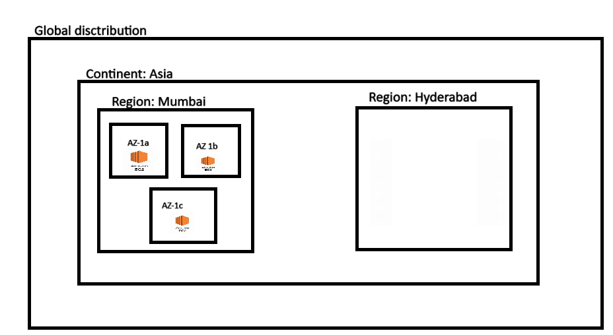

### **1. Regions**

* **Definition**: A *Region* is a **physical location** around the world where AWS clusters its **data centres**.
* Each region contains **multiple Availability Zones**.
* You choose a region based on **latency**, **cost**, or **data residency requirements**.

**🗺️ Examples:**

* us-east-1 → N. Virginia
* ap-south-1 → Mumbai
* eu-central-1 → Frankfurt

🟢 **As of 2025**, AWS has **30+ regions**

### **2. Availability Zones (AZs)**

* **Definition**: An AZ is one or more **data centres** with independent **power**, **cooling**, and **networking** within a Region.
* AZs are **physically separated**, often miles apart, for **fault tolerance**.
* Most regions have **at least 3 AZs** (some up to 6!).

✅ You deploy resources across AZs for **high availability and disaster recovery**

### **3. Edge Locations (CDN - CloudFront)**

* Edge locations are part of AWS **CloudFront**, a **Content Delivery Network (CDN)**.
* They **cache content** closer to users for **low latency** access (e.g., for videos, images, websites).
* 500+ edge locations across the globe.
* 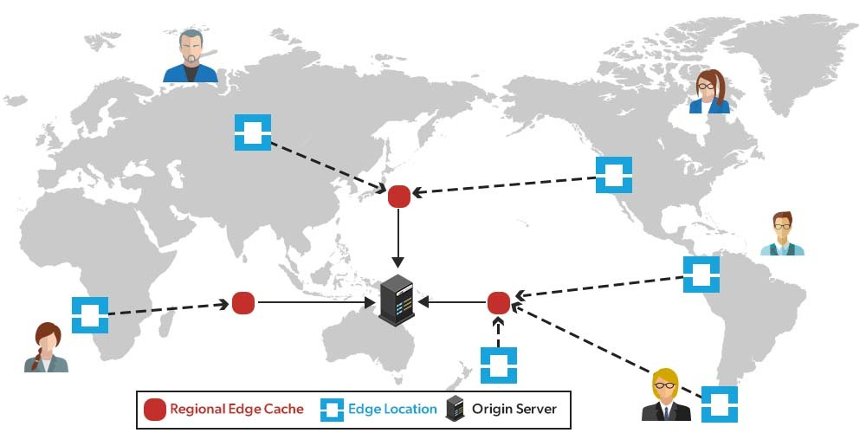

### **India**

* **Regions**: AWS has two regions in India:
  + **Asia Pacific (Mumbai)**: Launched in 2016
  + **Asia Pacific (Hyderabad)**: Launched in 2022
* **Availability Zones (AZs)**: Each region comprises **3 AZs**, totaling **6 AZs** in India.
* **Edge Locations**: AWS operates **33 CloudFront Edge Locations** across major Indian cities:
  + Mumbai (10)
  + New Delhi (7)
  + Chennai (7)
  + Bangalore (4)
  + Hyderabad (3)
  + Kolkata (2)

### **🌍 Worldwide**

* **Regions**: AWS spans **36 geographic regions** globally.
* **Availability Zones (AZs)**: There are **114 AZs** across these regions.
* **Edge Locations**: AWS has over **400 Edge Locations** in more than **90 cities** across **48 countries**, forming a vast global content delivery network.

AWS account sign-up

Server creation:

|  |  |
| --- | --- |
| Name | AWS terminology |
| Name | Name |
| OS | Choose OS |
| RAM-CPU | Instance type |
| Hard disk | EBS (Elastic Block Storage) |
| Networking | Networking (VPC, Subnets) |
| Password | Keypair |
| Firewall | Security group |
| Server | EC2 |

**VPC and Subnets**

## **☁️ VPC (Virtual Private Cloud)**

### **✅ Definition:**

A **VPC** is your **own isolated network** inside AWS where you can launch and manage AWS resources like EC2 instances, RDS databases, etc.

### **Class Notes:**

* It's like having your own **private data centre** in the cloud.
* VPC is a virtual network in AWS
* It offers isolated private network inside public network
* We can create max.5 VPCs in a region
* We will consider VPC is main network
* VPC works at region level
* VPC has subnets, these subnets count depends on VPC CIDR

### **🔐 Features:**

* Control over **IP address ranges** (via **CIDR** block like 10.0.0.0/16)
* Create **subnets** to organize resources
* Configure **route tables**, **internet gateways**, **NAT gateways**, and **security groups**
* Full control over **inbound and outbound traffic**

### **🎯 Example:**

* You create a VPC with CIDR block 10.0.0.0/16
* This means you have 65,536 IP addresses to work with
* You can now divide this VPC into **subnets**

## **🎯 Key Reasons to Use a VPC**

### **1. 🔐 Isolation & Security**

* Complete control over **who accesses what**
* Use **Security Groups** and **Network ACLs** to filter traffic
* Resources in your VPC are **not exposed to the public internet** unless you allow it

### **2. 🛠️ Custom Network Configuration**

* Define your **own IP address range** using CIDR (e.g., 10.0.0.0/16)
* Divide the network into **subnets** (public/private)
* Use **routing tables**, **internet gateways**, and **NAT gateways**

### **3. 🌍 Internet Control**

* Decide which resources should be **internet-facing** (via public subnets)
* Keep sensitive resources **private** and secure

### **4. 🧩 Integration with On-Premises Networks**

* Use **VPN** or **AWS Direct Connect** to link your data centre to AWS
* Hybrid cloud setup becomes easy

### **5. 📏 Compliance & Governance**

* Meet security policies, regulations (e.g., HIPAA, GDPR)
* Define **logging, monitoring, and audit** controls with VPC Flow Logs and CloudTrail

### **6. ⚙️ Control Over Network Routing**

* Customize traffic flow using **route tables**
* Use **private links**, **peering**, and **Transit Gateway** for advanced networking

## **🧱 Subnets**

### **✅ Definition:**

A **subnet** is a **subdivision** of your VPC’s IP address range.

It allows you to group and isolate resources **within** a VPC — typically based on functionality or access level.

### **🌐 Types of Subnets:**

|  |  |  |
| --- | --- | --- |
| **Type** | **Access** | **Typical Use Cases** |
| **Public** | Has access to Internet via **Internet Gateway** | Web servers, bastion hosts |
| **Private** | No direct internet access | Databases, application servers |
| **VPN-only** | For internal access via VPN or Direct Connect | Internal tools, legacy systems |

## **🎯 Top Reasons to Use Subnets**

### **1. 🔒 Security & Access Control**

* **Public Subnets**: For resources that need internet access (e.g., web servers)
* **Private Subnets**: For internal-only resources (e.g., databases, backend apps)
* Prevents sensitive data from exposure

### **2. 🌐 Internet Routing Management**

* Use **Internet Gateway** for public subnets
* Use **NAT Gateway** or **NAT Instance** to allow private subnets to access the internet **without being exposed**

### **3. 📍 Availability Zone Distribution**

* Place subnets in **different AZs** to improve **fault tolerance**
* Helps build **high availability** architecture (e.g., load-balanced servers across AZs)

### **4. 🧩 Organizational Clarity**

* Group similar resources (e.g., web tier, app tier, DB tier)
* Easier to manage and apply **specific routing and security rules**

### **5. 📈 Scalability & Optimization**

* Optimize traffic flow using custom **route tables** for each subnet
* Scale infrastructure easily within structured boundaries

### **🔁 Typical Subnet Setup in a VPC**

|  |  |  |
| --- | --- | --- |
| **Subnet Type** | **Example Use** | **Internet Access** |
| Public Subnet | Web server, Bastion host | Yes (via IGW) |
| Private Subnet | App server, DB server | No (unless via NAT) |
| Isolated Subnet | Backups, internal tools, security | No internet at all |

**Internet Gateway (IGW)**

## **🌐 Internet Gateway (IGW) – AWS Networking Notes**

### **✅ What is an Internet Gateway?**

An **Internet Gateway (IGW)** is a **horizontally scaled, redundant**, and **highly available** **AWS VPC component** that enables communication between:

* Resources in your **VPC** (e.g., EC2 instances) **and**
* The **internet**

It acts as a **bridge** between your VPC and the outside world.

### **🔄 What It Does**

* Enables **outbound** internet access from public subnets
* Allows **inbound** traffic from the internet to reach **publicly accessible resources**
* Works only with **public subnets** that have:
  + A **public IP** or **Elastic IP**
  + A route to the **IGW** in the **route table**

### **🛠️ How to Use IGW**

1. **Create a VPC**
2. **Create an IGW** and **attach it** to the VPC
3. Add a route in the **route table**:

Destination: 0.0.0.0/0 → Target: igw-xxxxxxxx

1. Launch an **EC2 instance** in a **public subnet**
2. Assign a **public IP** to the instance

### **🚫 What IGW Does NOT Do**

* It does **not provide NAT** (use **NAT Gateway** for private subnets)
* It does **not protect** your resources (use **Security Groups** and **NACLs** for that)

### **🔐 Security Considerations**

* Use **Security Groups** to control **who** can access your EC2 instance from the internet
* Public IP + IGW = **Internet-reachable instance**
* Remove public IP or IGW route to make instances private again

### **🧠 Real-Life Analogy:**

If a **VPC is a private neighbourhood**, the **Internet Gateway** is like the **main gate** to enter or leave. Only houses (instances) with permission (public IP and proper routing) can use it.

### **Class Notes:**

* We can’t attach multiple IGW to same VPC.
* **Public Subnet:** If internet routing is there between IGW and subnet through route table, then it is public subnet
* **Private Subnet:** If internet routing is not there between IGW and subnet through route table, then it is private subnet.

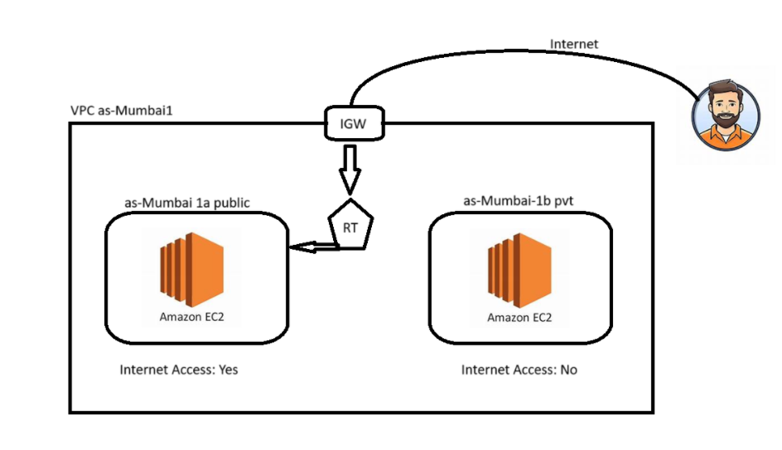

**Security Group**

### **🔐 What is a Security Group in AWS?**

A **Security Group (SG)** in AWS acts as a **virtual firewall** that controls **inbound and outbound traffic** to **EC2 instances** and other supported AWS resources within a **VPC**.

## **🎯 Key Points About Security Groups**

|  |  |
| --- | --- |
| **Feature** | **Description** |
| Scope | Works at the **instance level** (not subnet level) |
| Direction | Controls both **inbound** (incoming) and **outbound** (outgoing) traffic |
| Default Behaviour | **Denies all inbound**, **allows all outbound** by default |
| Stateful | Yes – return traffic is automatically allowed regardless of outbound rules |
| Attached To | EC2, RDS, Lambda ENIs, ELB, etc. |
| Max Rules Per Group | 60 inbound + 60 outbound (can request increase) |

## **🛠️ How Security Groups Work**

### **➕ Inbound Rules:**

Define **who can connect** to your instance and **on which port**.

|  |  |  |  |
| --- | --- | --- | --- |
| **Type** | **Protocol** | **Port Range** | **Source** |
| SSH | TCP | 22 | Your IP |
| HTTP | TCP | 80 | 0.0.0.0/0 (public) |
| RDP | TCP | 3389 | Admin’s IP |

### **➖ Outbound Rules:**

Define **where your instance can connect to**.

|  |  |  |  |
| --- | --- | --- | --- |
| **Type** | **Protocol** | **Port Range** | **Destination** |
| All traffic | All | All | 0.0.0.0/0 |

## **🔁 Stateful Behaviour**

* If **inbound** rule allows traffic in, the **outbound reply is automatically allowed**
* No need to manually define return rules

## **✅ Use Cases**

* Allow SSH only from your office IP
* Allow HTTP from the entire internet
* Restrict database access to app servers only (by SG ID)
* Block all outbound except specific IPs (for security lockdown)

## **🔒 Best Practices**

* Use **least privilege**: only open required ports/IPs
* Use **different SGs** for different layers (web, app, db)
* Regularly **review and update rules**
* Avoid using 0.0.0.0/0 unless necessary

### **🧠 Real-Life Analogy:**

A **Security Group** is like the **bouncer** at the entrance of your house (instance) — checking the list (rules) for who’s allowed in or out.

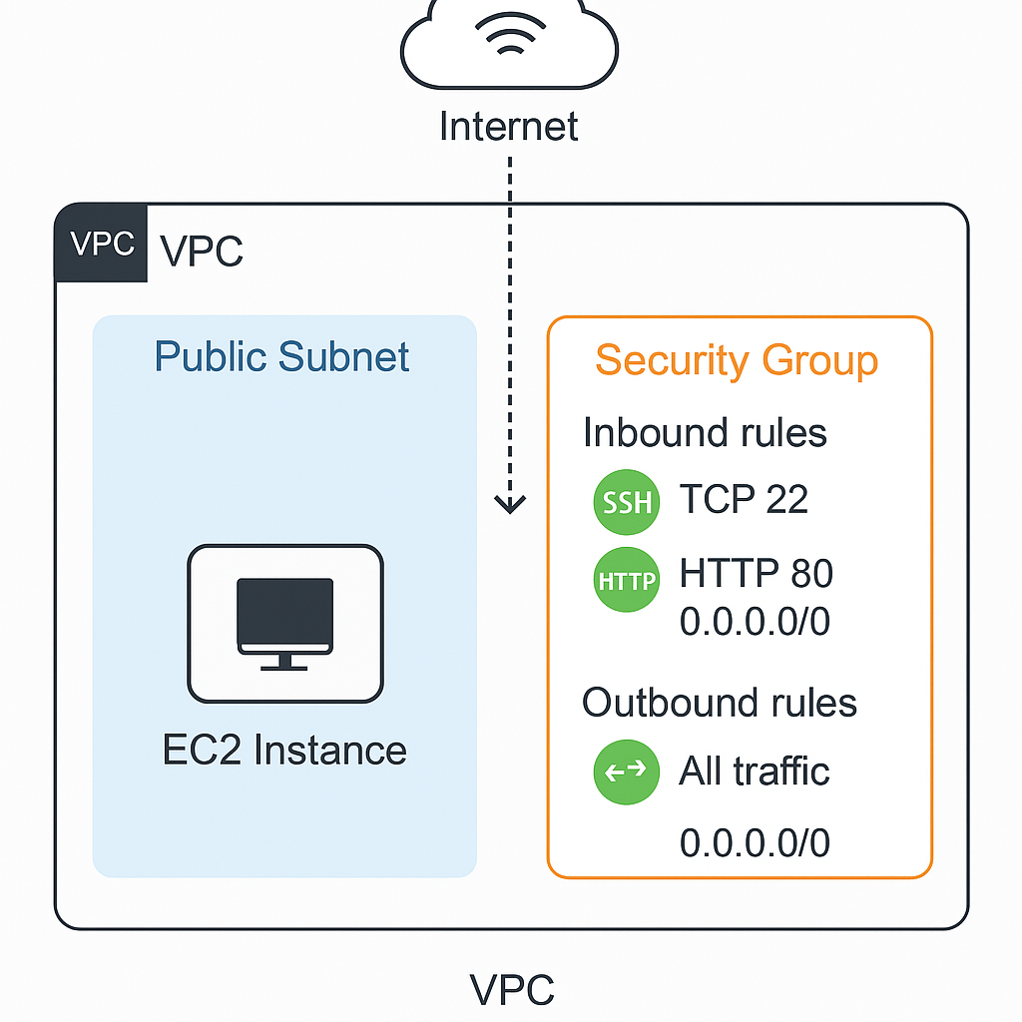**Class Notes:**

* SG is a security layer for the server which blocks unauthorized access and allow authorised traffic.
* We can attach security group to server level (EC2)
* We can create rules in SG to allow the permission
* Protocol: it is a set of rules and gives the instruction
* Port: Specific Access point

(Http-80, Https-443, SSH-22, RDB remote desktop protocol for Windows-3389)

Key Pair

### **🔐 What is a Key Pair in AWS?**

A **Key Pair** in AWS is used to **securely connect to EC2 instances** (virtual servers). It consists of two parts:

|  |  |  |
| --- | --- | --- |
| **Part** | **Stored Where** | **Purpose** |
| **Public key** | Stored by AWS (in EC2 instance) | Used to verify the identity of the connecting client |
| **Private key** | Downloaded and stored by you | Used to **log in via SSH** (Linux) or **RDP** (Windows) |

## **🎯 Why It’s Needed**

When you launch an EC2 instance, AWS installs the **public key** on the server. You use your **private key** to connect securely to that instance — no password required.

## **🛠️ How to Use a Key Pair**

1. **Create a key pair** from the AWS Console (RSA or ED25519)
2. Download the .pem file (your **private key**) – **only once**
3. Launch an EC2 instance and **associate it** with that key pair
4. Use terminal or tools like PuTTY to SSH into the instance:

ssh -i "your-key.pem" ec2-user@<EC2-public-IP>

## **🔐 Best Practices**

* Keep your .pem file **safe and secure**
* Never share your private key
* Change keys regularly and remove old key pairs
* Use **EC2 Instance Connect** as a backup if you lose the key

### **🧠 In Simple Terms:**

A **Key Pair** is like a **lock (public key) and key (private key)** to your EC2 instance. You keep the key, and AWS keeps the lock.

Note:

* Developers will get private key. Public key will be inside server.
* We can login to server to update and do any modification.
* We can reuse the key for multiple servers

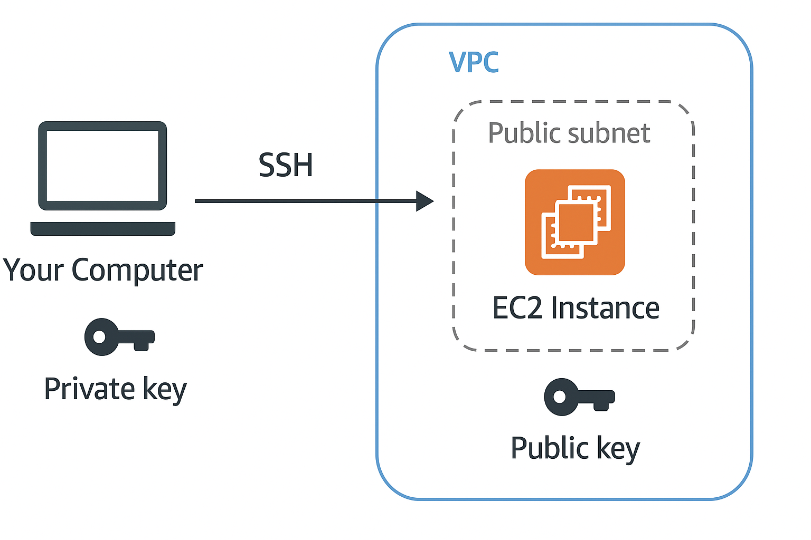

**Basic Steps to create a Server**

(One public and one private)

1. Create VPC by selecting region
2. Create 2 subnets (By default they are private)
3. Create IGW attach to VPC
4. Create Route table
5. Provide Routing from IGW to RT  
   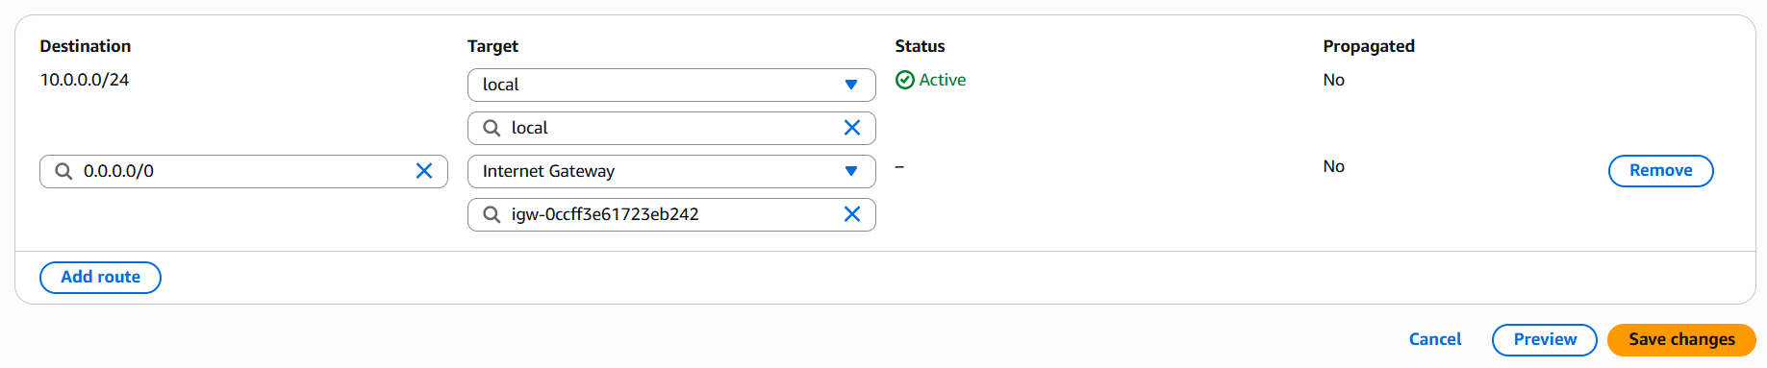
6. Provide routing from RT to Subnet which you want to make it public  
   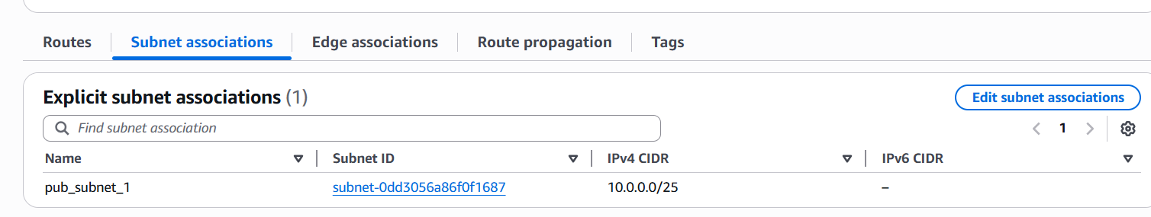
7. Create Security Group by allowing required inbound rule  
   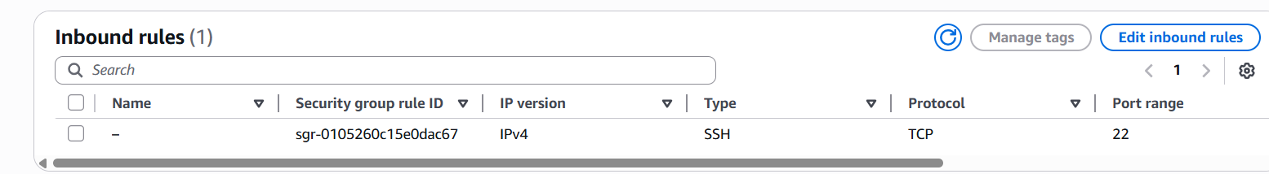
8. Launch Public Server into Public Subnet and Private Server into Private Subnet
9. Create key pair  
   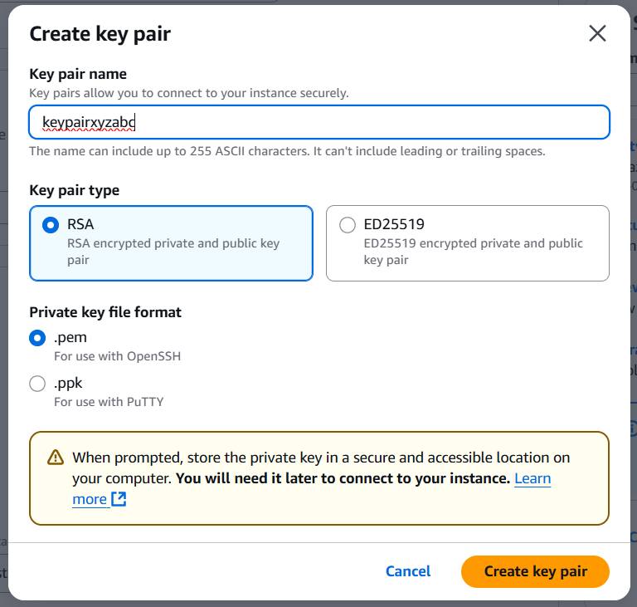
10. Test the Connection.

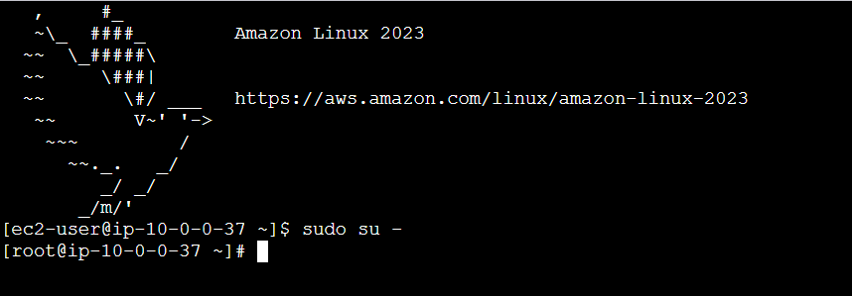

CIDR

### **📘 CIDR: Classless Inter-Domain Routing**

**CIDR (pronounced "cider")** is a method used to assign IP addresses and routing IP packets more efficiently.

### **🧠 What is a CIDR block?**

A **CIDR block** is an IP address followed by a **slash ("/") and a number**, like:

10.0.0.0/16

This tells you:

* **IP Range Start**: 10.0.0.0
* **Prefix Length (/16)**: First 16 bits are fixed
* **16** – Net Mask Value
* **Host Bits**: Remaining 16 bits for devices/hosts

### **🧮 Example CIDR Ranges**

|  |  |  |  |
| --- | --- | --- | --- |
| **CIDR Block** | **# of IPs** | **Usable IPs** | **Subnet Mask** |
| 10.0.0.0/8 | ~16 million | ~16 million | 255.0.0.0 |
| 10.0.0.0/16 | 65,536 | 65,534 | 255.255.0.0 |
| 10.0.0.0/24 | 256 | 254 | 255.255.255.0 |
| 192.168.1.0/28 | 16 | 14 | 255.255.255.240 |

### **💡 Why Use CIDR in AWS?**

In AWS:

* You define **VPC ranges** using CIDR blocks
* You divide those into **subnets** (each with its own CIDR)
* CIDR makes routing flexible, avoids wasted IPs

Let me know if you want help calculating CIDR ranges or visualizing subnets inside a VPC.

Note:

In AWS, **every subnet** (whether public or private) reserve **five IP addresses** from its CIDR block. These reserved IPs **cannot be used** by EC2 instances or other resources.

## **📌 Reserved IP Addresses in AWS Subnets**

When you create a subnet (e.g., 10.0.1.0/24), **AWS reserves 5 IPs**:

|  |  |
| --- | --- |
| **Reserved IP** | **Purpose** |
| **.0** (e.g., 10.0.1.0) | **Network address** (used to identify the subnet) |
| **.1** (e.g., 10.0.1.1) | Reserved for **VPC router** |
| **.2** (e.g., 10.0.1.2) | Reserved for **DNS** |
| **.3** (e.g., 10.0.1.3) | Reserved for **future use** |
| **.255** (e.g., 10.0.1.255) | **Broadcast address** (not used in AWS, but still reserved) |

### **📊 Example for /24 Subnet**

* CIDR block: 10.0.1.0/24
* Total IPs: 256
* Reserved: 5
* **Usable IPs: 251**

## **⚠️ Notes**

* This reservation happens **per subnet**, not per VPC.
* Even in small subnets like /30 (only 4 IPs), you’ll still lose 5 — which is why AWS **requires at least a /28 subnet** (16 IPs).

To **calculate usable IP addresses** per CIDR block and **pick the right CIDR** for your use case, you need to understand how CIDR notation works and how many addresses each block provides.

### **🔢 CIDR to Usable IPs Quick Reference**

|  |  |  |  |
| --- | --- | --- | --- |
| **CIDR** | **Total IPs** | **Usable IPs (AWS)\*** | **Use Case Example** |
| /32 | 1 | 0 | Single host (not subnettable) |
| /30 | 4 | 1 | Point-to-point links |
| /29 | 8 | 3 | Small services, test environments |
| /28 | 16 | 11 | Small apps, VPN |
| /27 | 32 | 27 | Small office |
| /26 | 64 | 59 | Medium services |
| /25 | 128 | 123 | Large app or DB layer |
| /24 | 256 | 251 | One full subnet, large network |
| /23 | 512 | 507 | Multiple services or environments |
| /22 | 1024 | 1019 | Large deployments |
| /21 | 2048 | 2043 | VPC-level usage |
| /16 | 65536 | 65531 | Entire VPC allocation |

*In AWS, 5 IPs are reserved per subnet:

* Network address
* Broadcast address (even though AWS doesn’t use it)
* First 3 usable for internal AWS operations

### **📌 Formula to Calculate Usable IPs**

**Usable IPs = (2^(32 - CIDR)) - Reserved IPs**

Usually:

* Reserved IPs = 5 in AWS
* For traditional networks (on-prem), it's 2 (network & broadcast)

Why 32?

Ex 10.0.0.0/24  
2^ (32-24) =2^8=265

|  |  |  |  |
| --- | --- | --- | --- |
| 10 | 0 | 0 | 0 |
| 1 byte | 1 byte | 1 bye | 1byte |
| 8 bits | 8 bits | 8 bits | 8 bits |

### **✅ Picking the Right CIDR**

Ask these questions:

1. **How many hosts do I need in the subnet?**
   1. Use the table above to match your count.
   2. E.g., need 50 hosts → pick /26 (59 usable).
2. **How many subnets do I need within a VPC?**
   1. Your VPC CIDR (e.g., /16) limits total IPs.
   2. Divide larger CIDRs into smaller ones (/24, /25, etc.).
3. **Future scalability needed?**
   1. Always round up. If you need 110 hosts, don't pick /25 (123), instead plan for /24 (251 usable) for growth.

### **🧮 Example**

**Use Case**: You need 4 subnets:

* 1 public with 20 IPs
* 2 private with 50 IPs each
* 1 DB subnet with 10 IPs

Suggested Subnets:

* Public: /27 (32 total, 27 usable)
* Private A & B: /26 (64 total, 59 usable)
* DB: /28 (16 total, 11 usable)

You could allocate a /24 (256 IPs) and divide it accordingly.

### **Class Note:**

* By deciding CIDR, we can create VPC and Subnets
* CIDR decides network size of VPC and Subnets
* We can use 10.x.x.x, 172.x.x.x, 192.x.x.x series
* CIDR will allocate private IPs
* Regarding public IPs, we can allocate through AWS pool from backend
* Remaining series are for public. So that it should not overlap IPs.
* As per AWS, CIDR block size must be between /16 to /28
* 10.0.0.0/16, total IPs -> 2^ 16= 65536
* Subnet CIDR range always in the range or equal range

### **Subnets count & IP ranges**

**VPC CIDR- 10.0.0.0/24 means total IPs 256**

**For 2 Subnets**

|  |  |  |
| --- | --- | --- |
| Total IPs | 128 | 128 |
| IP range | 0-127 | 128-255 |
| Subnet CIDR | 10.0.0.0/25 to 10.0.0.127/25 | 10.0.0128/25 to 10.0.0.255/25 |

**For 4 Subnets**

|  |  |  |  |  |
| --- | --- | --- | --- | --- |
| Total IPs | 64 | 64 | 64 | 64 |
| IP range | 0-67 | 68-127 | 128-191 | 192-255 |
| Subnet CIDR | 10.0.0.0/26 | 10.0.0.64/26 | 10.0.0.128/26 | 10.0.0.192/26 |

**For 8 Subnets net mask value is /27**

**BASTION HOST**

## **🛡️ What is a Bastion Host in AWS?**

A **Bastion Host** (also known as a **Jump Server** or **Jump Box**) is a **specially designated EC2 instance** that provides secure access to instances in **private subnets** of your AWS VPC.

### **🧭 Why Use a Bastion Host?**

**In AWS:**

* **Private subnets** are **not directly accessible from the internet** for security. **EC2 instances in private subnets** cannot be directly accessed from the internet.
* To manage them (e.g., SSH into an EC2), you need a secure way in — that’s the **Bastion Host**. Instead of opening SSH access to all private instances, you use a **bastion host in a public subnet** as a secure entry point.

## **🗺️ How It Works**

1. **Bastion host** is launched in a **public subnet** with a **public IP**.
2. Your local machine connects to the **bastion host via SSH** using a key pair.
3. From the bastion host, you can SSH into EC2 instances in **private subnets**.

### **🏗️ Architecture Overview**

Internet  
 │  
 ▼  
[ Bastion Host (Public Subnet) ] ◀─── SSH from your laptop  
 │  
 ▼  
[ EC2 Instances (Private Subnet) ] ◀─── SSH from Bastion Host

* Bastion is in a **Public Subnet** with a **Public IP**
* Private EC2s are in a **Private Subnet** with **only private IPs**
* SSH is only allowed from Bastion to Private EC2s

### **🔐 Security Best Practices**

|  |  |
| --- | --- |
| **Tip** | **Why** |
| Only allow your IP (via SG) | Prevents public access from others |
| Use key pairs / SSH keys | Strong authentication |
| Disable root login | Reduces risk of unauthorized access |
| Use Amazon **Session Manager** | Avoids needing public IPs or SSH altogether |
| Use **CloudWatch Logs** or **S3** for audit | For tracking SSH sessions and commands |

### **🔧 Basic Setup Steps**

1. **Create a VPC**
2. **Create two subnets**:
   1. Public subnet (for Bastion Host)
   2. Private subnet (for app/database EC2s)
3. **Launch a Bastion EC2 instance** in the public subnet
4. Assign it a **public IP**
5. **Configure security groups**:
   1. Bastion SG: allow SSH (port 22) from your IP
   2. Private EC2 SG: allow SSH from Bastion’s **private IP** or **SG**

**LINUX COMMANDS**- to connect to servers

**🧠 Analogy:**

Imagine the bastion host as the **front gate guard** to a secure compound. Instead of giving everyone keys to every building (EC2), you give access to the gate (bastion) and only allow movement inside after verification

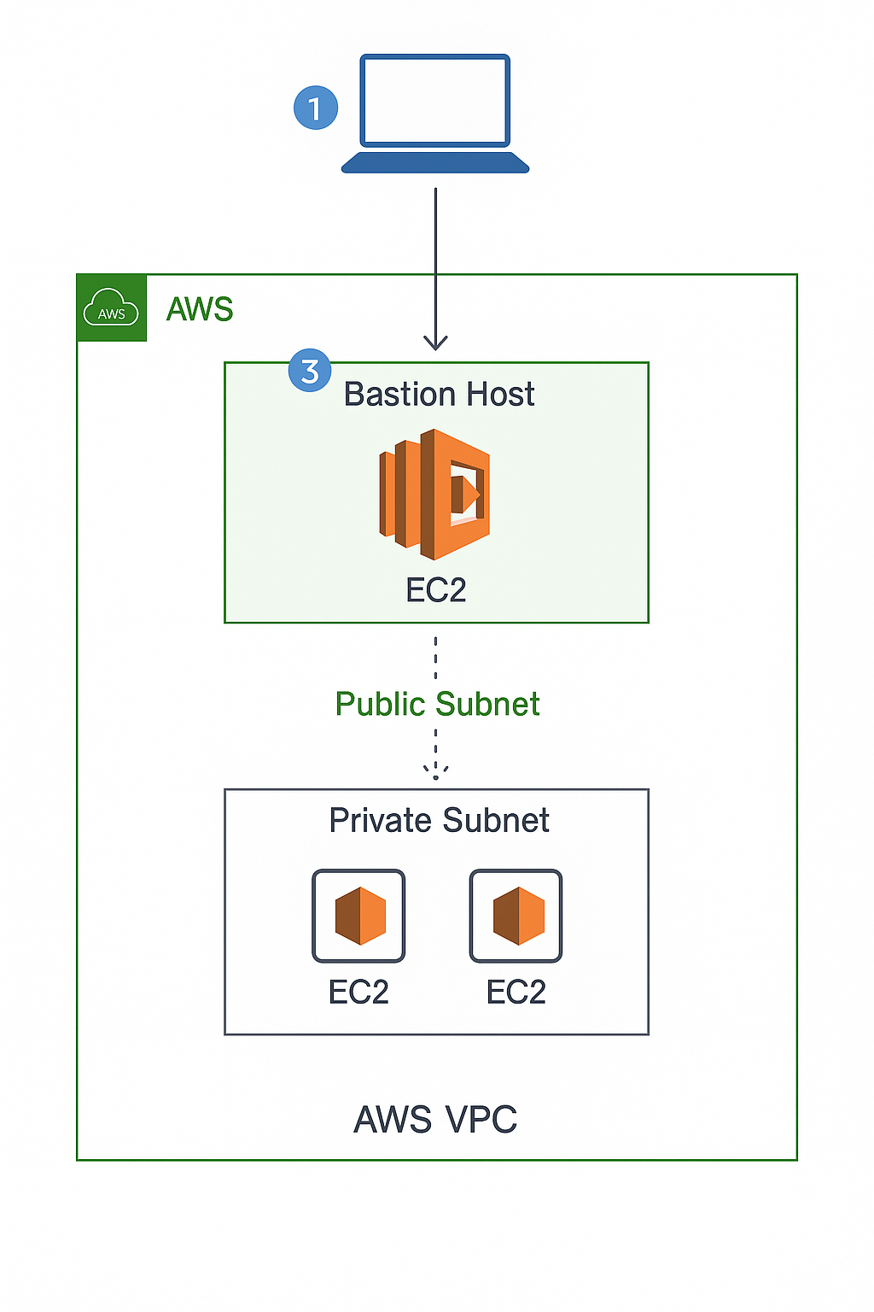

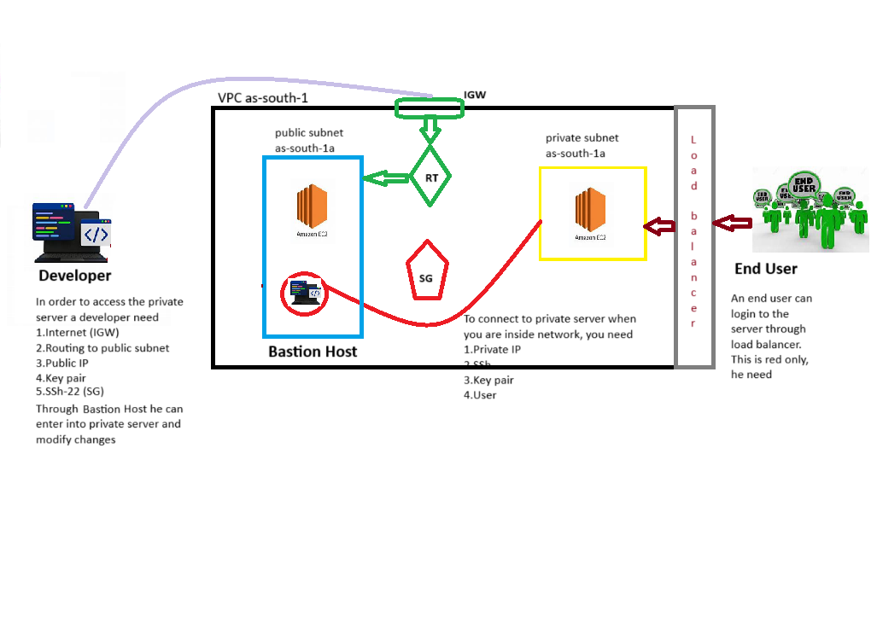

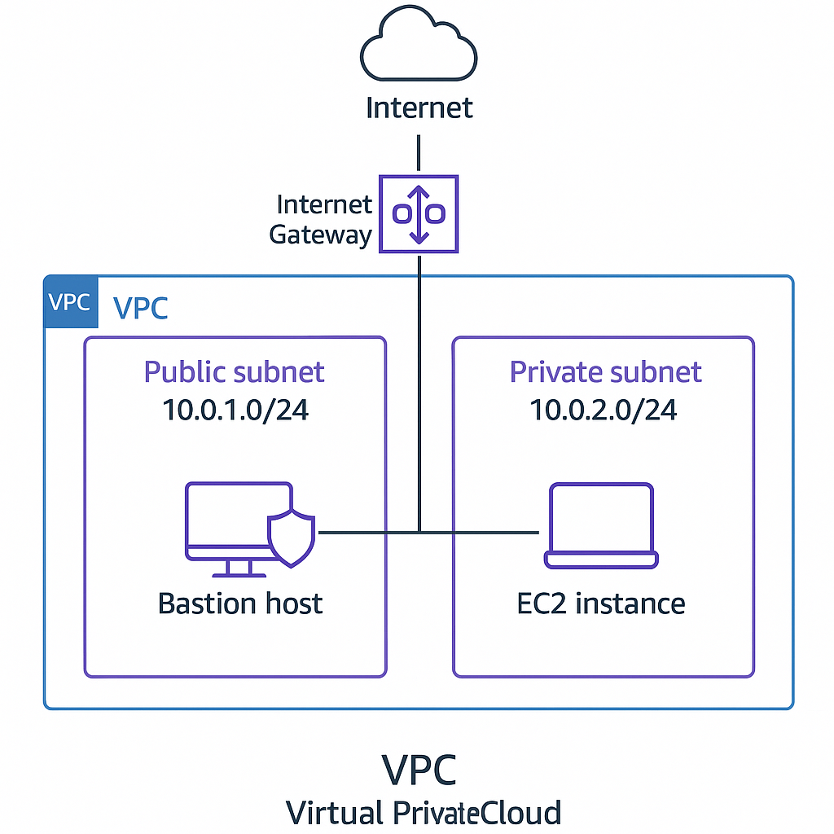

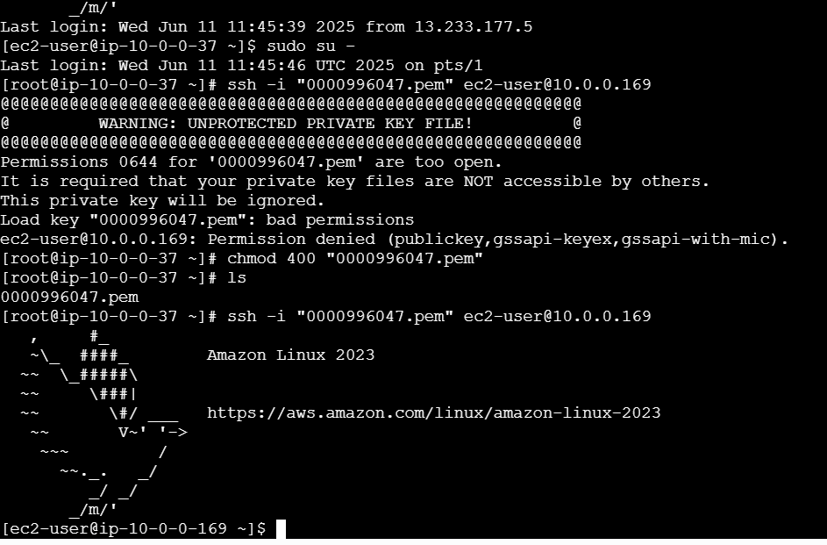

**NAT Gateway**

### **🌐 What is a NAT Gateway in AWS?**

A **NAT Gateway** (Network Address Translation Gateway) allows **instances in a private subnet** to **access the internet** or other AWS services **without exposing them to inbound internet traffic**.

## **🎯 Why Use NAT Gateway?**

* Private instances often need internet access (e.g., for updates, patching).
* NAT Gateway provides **secure outbound access** while **blocking inbound connections**.

## **🗺️ How It Works**

1. **Instances in a private subnet** send outbound traffic (e.g., to yum update or apt-get) to the **NAT Gateway**.
2. The NAT Gateway **translates** private IPs to its **own public IP**.
3. The internet **responds to the NAT Gateway**, which then **forwards the traffic back** to the instance.

## **🧱 Key Requirements**

* Place NAT Gateway in a **public subnet**.
* Attach an **Elastic IP** to the NAT Gateway.
* Update the **route table of the private subnet**:
  + 0.0.0.0/0 → NAT Gateway ID

## **🔁 NAT Gateway vs Internet Gateway**

|  |  |  |
| --- | --- | --- |
| **Feature** | **NAT Gateway** | **Internet Gateway** |
| Traffic Direction | Outbound only | Inbound and outbound |
| Used By | Private subnet instances | Public subnet instances |
| Requires Public IP? | Yes (Elastic IP attached to NAT GW) | Yes (on the EC2 instance itself) |
| Protects Resources? | Yes (no inbound traffic allowed) | No (requires security group hardening) |

## **💡 Types of NAT in AWS**

* **NAT Gateway (managed service)**: Scalable, highly available, easy to set up
* **NAT Instance (self-managed EC2)**: Customizable but requires maintenance

### **🧠 Analogy:**

Think of the NAT Gateway as a **secure outbound-only door** — your private instances can go out to the internet, but nothing from outside can come in through it.

### **Class Note:**

* NAT allows internet to private server in secure way
* NAT allows unidirectional access
* NAT should be created inside the public server first. NAT gets internet now.
* NAT gets STATIC IP
* Since NAT is inside public subnet, so no need to connect again to Public Router.

### **✅ Step-by-Step: Access Private Server via NAT Gateway (using Bastion Host)**

To connect to a **private EC2 instance through a NAT Gateway**, you **can’t directly SSH** into the private server from the internet, because NAT Gateway only allows **outbound** connections. So, the correct step-by-step process is to connect **indirectly**, using a **bastion host** or other method. Here’s the proper way:

**Prerequisite:** You must already have a **NAT Gateway** (for outbound access) and a **Bastion Host** (for inbound access) setup.

#### **🔧 Infrastructure Setup**

|  |  |  |
| --- | --- | --- |
| **Resource** | **Location** | **Notes** |
| **NAT Gateway** | Public Subnet | For outbound traffic from private subnet |
| **Bastion Host** | Public Subnet | Accessible via SSH (has public IP) |
| **Private EC2** | Private Subnet | No public IP |

#### **🚀 Step-by-Step Connection Process**

1. **Connect to Bastion Host**

ssh -i your-key.pem ec2-user@<bastion-public-ip>

1. **From Bastion, SSH into Private EC2**

ssh -i your-key.pem ec2-user@<private-ec2-private-ip>

### **🔁 Private EC2 to Internet via NAT Gateway (Outbound Access)**

If you want the **private instance to access internet**, make sure:

* NAT Gateway is in a **public subnet**.
* Private subnet's **route table** has:

Destination: 0.0.0.0/0 → Target: NAT Gateway ID

* The **security group** and **NACLs** allow the outbound traffic.

### **🧠 Summary:**

* **NAT Gateway is not used for inbound SSH access**.
* Use a **bastion host** to reach private EC2.
* NAT Gateway allows private EC2 to access internet only for outbound (e.g., installing software).

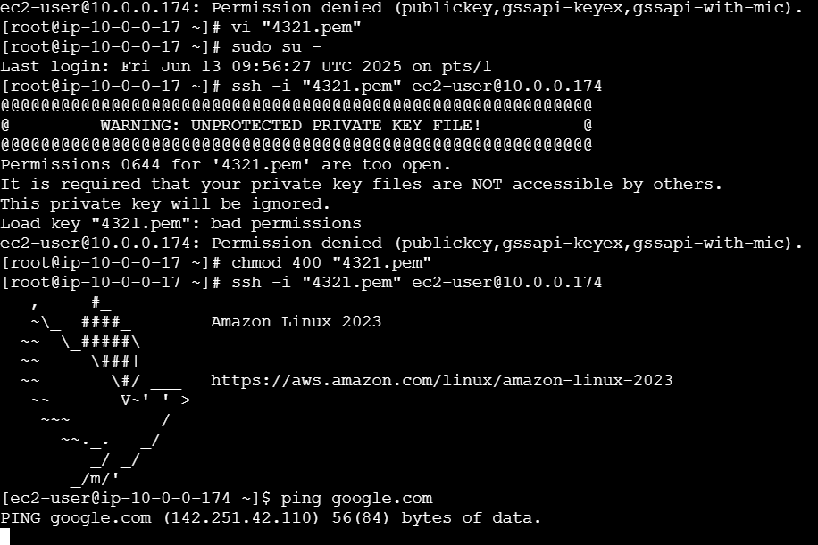

**Load Balancer**

### **⚖️ What is a Load Balancer in AWS?**

An **AWS Load Balancer** is a fully managed service that **distributes incoming traffic across multiple targets** (like EC2 instances, containers, IP addresses) to ensure:

* **High availability**
* **Fault tolerance**
* **Scalability**

## **📚 Types of Load Balancers in AWS (via Elastic Load Balancing - ELB)**

|  |  |  |
| --- | --- | --- |
| **Load Balancer Type** | **Layer** | **Use Case** |
| **Application Load Balancer (ALB)** | Layer 7 (HTTP/HTTPS) | Web apps, path-based or host-based routing |
| **Network Load Balancer (NLB)** | Layer 4 (TCP/UDP) | High-performance, low-latency apps |
| **Gateway Load Balancer (GWLB)** | Transparent, Layer 3/4 | Third-party appliances like firewalls |
| **Classic Load Balancer (CLB)** | Layer 4 & 7 (legacy) | Old generation, limited features |

## **🧠 Key Features**

|  |  |
| --- | --- |
| **Feature** | **Description** |
| **Health Checks** | Routes traffic only to healthy targets |
| **Auto Scaling Support** | Works with auto scaling groups |
| **Sticky Sessions** | ALB/CLB support session stickiness |
| **SSL Termination** | ALB/NLB can handle HTTPS/SSL encryption |
| **Cross-Zone Load Balancing** | Distributes traffic evenly across all AZs |

## **🔁 Example Workflow (ALB)**

1. Client makes an HTTP request to the **ALB DNS name**
2. ALB forwards request to the **target group** (set of EC2s)
3. ALB chooses a **healthy target** (via health checks)
4. Traffic is **distributed evenly or based on rule conditions**

## **🧰 Common Use Cases**

* Serving a **web app with multiple EC2 instances**
* Automatically rerouting traffic during **instance failures**
* Directing traffic based on URL path (e.g., /api vs /admin)
* Load balancing to **Fargate or ECS containers**

## **🔒 Security Integration**

* Works with **Security Groups**
* Can be fronted by **WAF (Web Application Firewall)**
* Supports **HTTPS** with certificate management (ACM)

### **🧠 Analogy:**

Think of a **load balancer** as a **traffic police officer** who directs cars (requests) to the right roads (servers) so no road gets too crowded or blocked.

**Target Group**

### **🎯 What is a Target Group in AWS?**

In AWS, a **Target Group** is a logical grouping of resources (called **targets**) that a **Load Balancer** (ALB or NLB) can forward traffic to.

## **🔍 Why Target Groups?**

* Allow you to organize backend resources like:
  + EC2 instances
  + ECS containers
  + IP addresses
  + Lambda functions
* Load Balancers use **Target Groups** to determine *where to send traffic* based on rules and health checks.

## **🧱 Target Group Components**

|  |  |
| --- | --- |
| **Component** | **Description** |
| **Targets** | EC2 instances, IPs, containers, etc. |
| **Port** | Port on which the targets receive traffic |
| **Health Check** | Mechanism to monitor target health (protocol, path, interval, etc.) |
| **Target Type** | instance, ip, or lambda |

## **🧰 Step-by-Step: Create and Attach Target Group to ALB**

### **✅ Step 1: Create a Target Group**

1. Go to **EC2 Dashboard → Target Groups**
2. Click **Create target group**
3. Choose:
   1. Target type: Instance, IP, or Lambda
   2. Protocol: HTTP or HTTPS
   3. Port: e.g., 80 or 8080
   4. VPC: select the VPC of your instances
4. Configure **health checks** (e.g., /, every 30s)
5. Click **Next** and **register targets**
   1. Choose EC2 instances and ports
6. Click **Create target group**

### **✅ Step 2: Create an Application Load Balancer**

1. Go to **EC2 Dashboard → Load Balancers**
2. Click **Create Load Balancer → Application Load Balancer**
3. Set:
   1. Name
   2. Scheme: internet-facing or internal
   3. IP type: IPv4 or Dualstack
   4. Listeners: e.g., HTTP:80 or HTTPS:443
4. Choose **VPC and subnets** across **2+ AZs**
5. Click **Next**

### **✅ Step 3: Configure Listener and Forwarding**

1. Add a **listener rule**:
   1. Action: **Forward to target group**
   2. Choose the **target group** you created earlier
2. Click **Create**

### **✅ Step 4: Test the Setup**

* Access your ALB using its **DNS name**
* Traffic will be routed to the healthy targets in your target group

## **🔒 Security Note**

* Ensure your **Security Group** on EC2 allows inbound traffic **from the Load Balancer’s SG**
* Health check paths (e.g., /) must be accessible

### **🧠 Analogy:**

A **Target Group** is like a **department** in a company. The Load Balancer is the **receptionist**, forwarding each client to the correct department (target group) based on the request type.

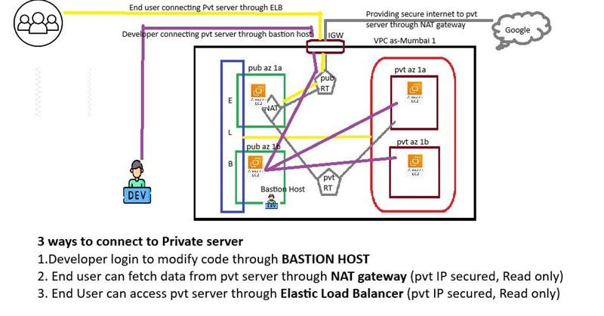

Class Notes

* Load Balancer is a service which redirects user request into healthy server
* It will also balance the load and gives a single endpoint to redirect into multiple servers
* Round Robin methos is the default method
* We can improve security since server IP is not exposed

Pre-Requisites

* To create load balancer minimum two subnets are required  
  Note: Load balancer can handle internal and external traffic
* For external traffic-minimum 2 public subnets are required
* For internal traffic-minimum 2 private subnets are required
* Ensure that two subnets should create in two different AZ’s not in same AZ for disaster recovery scheme to get HA
* Private servers and ELB registered AZ’s should be same. If servers are running in different AZ’s where LB has not registered, then LB will be unable send traffic to those servers  
  Ex: LB registered to 1a and 1b-->private servers also should run 1a and 1b only
* To redirect traffic into servers by load balancer, server should be registered in TG and same server should run in AZ where load balancer registered AZ’s

## **3-Tier Architecture**

## **🏗️ What is 3-Tier Architecture?**

**3-tier architecture** is a client-server software architecture pattern that separates applications into three logical layers:

1. **Presentation Tier (Web Tier)**
2. **Application Tier (Logic Tier)**
3. **Data Tier (Database Tier)**

This separation improves **scalability**, **maintainability**, and **security**.

### **🖥️ 1. Web Server (Presentation Tier)**

* **Role**: Handles all **HTTP/S requests** from the user's browser.
* **Serves**: Static content like HTML, CSS, JS, and forwards dynamic requests to the application server.
* **Examples**: Apache, Nginx, AWS Elastic Load Balancer

🔸 Think of this as the "front desk" – it accepts the request and passes it on.

### **🧠 2. Application Server (Logic Tier)**

* **Role**: Processes business logic handles dynamic content.
* **Executes**: Code written in Java, Python, PHP, .NET, Node.js, etc.
* **Communicates**: With both the Web Server and Database Server.
* **Examples**: Tomcat, JBoss, Node.js, Django, Spring Boot

🔸 This is like the "middle office" – it interprets, calculates, and makes decisions.

### **🗄️ 3. Database Server (Data Tier)**

* **Role**: Stores and manages **application data**.
* **Handles**: SQL queries, data integrity, and backups.
* **Examples**: MySQL, PostgreSQL, MongoDB, Amazon RDS, DynamoDB

🔸 This is the "vault" – where all the data is securely stored and retrieved.

## **🧰 How it Works – Example Flow**

1. A user visits [www.example.com/login](https://www.example.com/login).
2. The **Web Server** receives the request.
3. It forwards it to the **Application Server**, which verifies credentials.
4. The **Application Server** queries the **Database Server** for user data.
5. Based on the response, the app server sends a response back to the web server.
6. The **Web Server** sends the result to the user.

### **🎯 Benefits of 3-Tier Architecture**

|  |  |
| --- | --- |
| **Advantage** | **Why it matters** |
| 🔧 Scalability | Each tier can scale independently |
| 🔐 Security | Database is isolated from public access |
| 🧹 Maintainability | Easier to update logic without affecting UI or data |

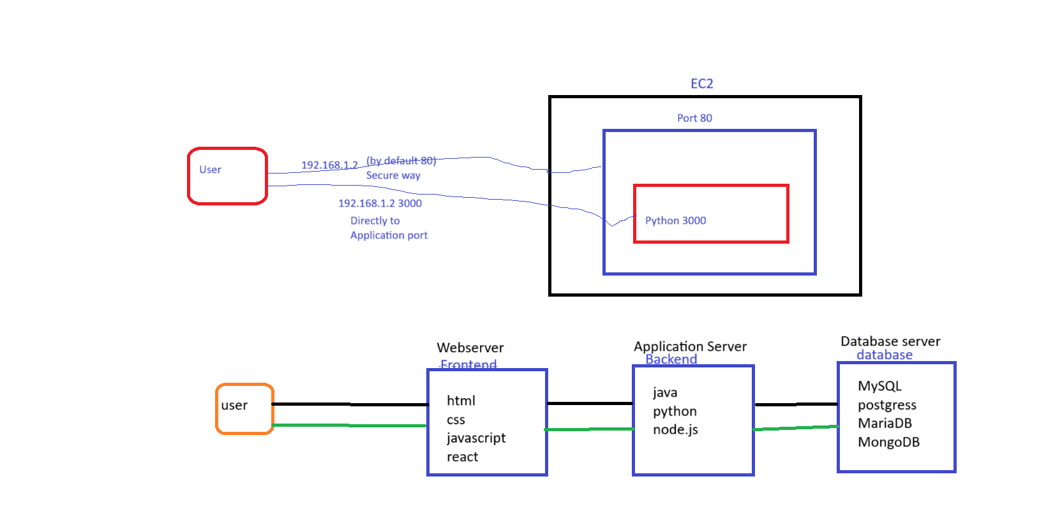

**LINUX COMMANDS**- Install Apache web server

***yum install httpd –y***  to Install Apache web server

***systemctl start httpd*** to start web server

***cd /var/www/html*** to set default path

***vi index.html is*** default fine name of html

**Write html code then enter ‘esc’ and enter :wq! To save**

**Auto Scaling Group**

### **📈 What is an Auto Scaling Group (ASG) in AWS?**

An **Auto Scaling Group** (ASG) is a feature of Amazon EC2 Auto Scaling that **automatically manages a group of EC2 instances**. It **adds** or **removes instances** based on demand, helping you maintain application availability and reduce costs.

## **🔧 Key Components of ASG**

|  |  |
| --- | --- |
| **Component** | **Description** |
| **Launch Template** or **Launch Configuration** | Defines the instance type, AMI, key pair, security groups, etc. |
| **Minimum Size** | Minimum number of EC2 instances in the group |
| **Maximum Size** | Maximum number of instances allowed |
| **Desired Capacity** | Ideal number of instances the group maintains |
| **Scaling Policies** | Rules to scale in/out based on CloudWatch metrics |
| **Health Checks** | Determines if an instance is healthy (EC2 or ELB checks) |
| **Target Group** | (Optional) Used if behind a load balancer |

## **🚀 Step-by-Step Workflow**

1. **Create a Launch Template**
   1. Define AMI, instance type, network, and key pair.
2. **Create Auto Scaling Group**
   1. Select VPC and subnets (usually across multiple AZs).
   2. Attach the Launch Template.
   3. Set min, max, and desired instance count.
   4. (Optional) Attach a Load Balancer Target Group.
   5. Define Health Check Grace Period.
3. **Configure Scaling Policies**
   1. Use **Target Tracking** (e.g., keep CPU at 60%)
   2. Or define **Step Scaling** or **Scheduled Scaling**
4. **Monitoring & Logging**
   1. Use **Amazon CloudWatch** for tracking metrics and triggers.

## **📚 Example Use Case**

Let’s say you run a web app:

* Set **min = 2**, **max = 6**, **desired = 2**
* If CPU > 70% for 5 minutes, ASG launches more EC2s
* If CPU < 30% for 10 minutes, ASG terminates excess EC2s

## **🧠 Benefits of ASG**

* ✅ High Availability
* ✅ Cost Optimization
* ✅ Resilience (replaces unhealthy instances)
* ✅ Integration with Load Balancers

### **🔒 Security Reminder:**

Ensure your **EC2s have correct IAM roles**, **security groups**, and **subnet access** to scale safely.

Class Notes:

Rules/Challenges

* ASG must create servers with same application   
  Solution- Create AMI
* ASG must create servers in same target group where ELB registered/configured  
  Solution- Select extisting ELB while configuring network
* ASG must create servers with same configurations Ex; Same key, SG, Instance type   
  Solution-Launch Template
* ASG must create servers in same AZ’s where load balancers registered.  
  Solutions- Select AZ while configuring network

# **AWS CLI Step-by-Step Guide: EC2, S3, IAM, Route 53, and More**

## **1. Configure AWS CLI**

aws configure

Provide Access Key, Secret Key, Default region, and Output format (e.g., json)

## **2. EC2 (Elastic Compute Cloud)**

List instances: aws ec2 describe-instances

Launch instance: aws ec2 run-instances --image-id ami-xyz --count 1 --instance-type t2.micro --key-name MyKey --security-groups my-sg

Stop instance: aws ec2 stop-instances --instance-ids i-1234567890abcdef0

Start instance: aws ec2 start-instances --instance-ids i-1234567890abcdef0

Terminate instance: aws ec2 terminate-instances --instance-ids i-1234567890abcdef0

## **3. S3 (Simple Storage Service)**

Create bucket: aws s3 mb s3://my-bucket-name

List buckets: aws s3 ls

Upload file: aws s3 cp myfile.txt s3://my-bucket-name/

Download file: aws s3 cp s3://my-bucket-name/myfile.txt .

Delete bucket: aws s3 rb s3://my-bucket-name --force

## **4. IAM (Identity and Access Management)**

List users: aws iam list-users

Create user: aws iam create-user --user-name myuser

Attach policy: aws iam attach-user-policy --user-name myuser --policy-arn arn:aws:iam::aws:policy/AmazonS3FullAccess

Create access key: aws iam create-access-key --user-name myuser

## **5. Route 53**

List hosted zones: aws route53 list-hosted-zones

Create hosted zone: aws route53 create-hosted-zone --name example.com --caller-reference 20250708

List record sets: aws route53 list-resource-record-sets --hosted-zone-id ZONEID

## **6. CloudWatch Logs**

List log groups: aws logs describe-log-groups

List log streams: aws logs describe-log-streams --log-group-name my-log-group

Get log events: aws logs get-log-events --log-group-name my-log-group --log-stream-name my-log-stream

## **7. RDS (Relational Database Service)**

List DB instances: aws rds describe-db-instances

Create DB instance: aws rds create-db-instance --db-instance-identifier mydb --db-instance-class db.t2.micro --engine mysql --master-username admin --master-user-password pass1234 --allocated-storage 20

Delete DB instance: aws rds delete-db-instance --db-instance-identifier mydb --skip-final-snapshot

## **8. CloudFormation**

Deploy stack: aws cloudformation create-stack --stack-name mystack --template-body <file://template.yaml>

Delete stack: aws cloudformation delete-stack --stack-name mystack

# **MySQL Setup & Connection Guide (EC2 & RDS)**

## **Step 1: Install MySQL Community Server on EC2 (Amazon Linux 2023)**

sudo rpm --import <https://repo.mysql.com/RPM-GPG-KEY-mysql-2022>

sudo dnf clean all

sudo rm -rf /var/cache/dnf

sudo dnf install -y mysql-community-server

Note: GPG key issues were resolved by importing the correct keys and cleaning cache.

## **Step 2: Start and Enable MySQL Server**

sudo systemctl start mysqld

sudo systemctl enable mysqld

Check status: sudo systemctl status mysqld

## **Step 3: Get Temporary Root Password**

sudo grep 'temporary password' /var/log/mysqld.log

**Use this password to log in as root.**

## **Step 4: Log In to Local MySQL on EC2**

mysql -u root -p (use the temporary password)

**Paste the temporary password (invisible as you type)**.

## **Step 5: Reset Expired Root Password**

ALTER USER 'root'@'localhost' IDENTIFIED BY 'NewSecureRootPass123!';

You saw:  
ERROR 1820 (HY000): You must reset your password using ALTER USER...

✅ Fix:  
ALTER USER 'root'@'localhost' IDENTIFIED BY 'NewSecureRootPass123!';

## **Step 6: Confirm Connection to Local MySQL**

You should see: Server version: 8.0.42 MySQL Community Server – GPL

**You're connected to MySQL on EC2, not RDS**.

## **Step 7: Connect to Amazon RDS**

mysql -h database-1.cjq262o4wd21.ap-south-1.rds.amazonaws.com -u admin -p

**Enter your RDS password (invisible as you type).**

**If successful, you’ll see:**

**Server version: 8.0.xx Source distribution**

## **Step 8: Common MySQL Commands**

SHOW DATABASES;

CREATE DATABASE myappdb;

CREATE USER 'myuser'@'%' IDENTIFIED BY 'StrongPass123!';

GRANT ALL PRIVILEGES ON myappdb.* TO 'myuser'@'%';

FLUSH PRIVILEGES;

USE myappdb;

CREATE TABLE users (id INT AUTO_INCREMENT PRIMARY KEY, name VARCHAR(50), email VARCHAR(100));

## **Local MySQL vs Amazon RDS**

|  |  |  |
| --- | --- | --- |
| Detail | Local MySQL (EC2) | Amazon RDS |
| Server version | Community Server - GPL | Source distribution |
| Connected with | mysql -u root -p | mysql -h <RDS-endpoint> -u -p |
| Installed manually | Yes | No (AWS-managed) |
| Requires systemd start | Yes | No (managed by AWS) |

